**To Flush or Not to Flush??** 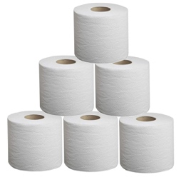

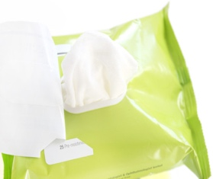

[This Photo](https://thenotice.net/2015/04/neutrogena-naturals-bioderma-make-up-wipes-review/) by Unknown Author is licensed under [CC BY-NC-ND](https://creativecommons.org/licenses/by-nc-nd/3.0/)

Toilet paper is designed to break down when it gets wet. “Flushable” wipes are small enough to fit in the toilet and resemble toilet paper but what happens when they get wet?

This is a science experiment to test if “flushable wipes really dissolve.

**MATERIALS:**

* 2 CLEAR JARS WITH LIDS
* TOILET PAPER
* “FLUSHABLE” WIPES

**INSTRUCTIONS:**

1. Assemble into groups of three.
2. Fill two clear jars with water
3. Add two squares of toilet paper to one jar
4. Add a “flushable” wipe to the second jar
5. Tightly close the lids on both jars
6. One partner shakes the jar with the toilet paper, the second partner shakes the jar with the “flushable wipe” while the third partner counts to 60.
7. Observe if either the toilet paper or the wipe dissolved more.

What happens if you shake them again? What if you touch them with your fingers? Do they fall apart?

After this experiment, do you think it’s a good idea to flush wipes down the toilet? Why not?

What impact do you think the wipes have on pipes in your bathroom and the sewer system?

Extra Credit: What is a “fatberg”?